**SHENZHEN** **LDROBOT CO., LTD.**

**DTOF LiDAR LD06 SPECIFICATION**

|  |  |  |
| --- | --- | --- |
| Product Name | ： | DTOF LiDAR_LD06 |
| Description | ： | DTOF COAXIAL BRUSHLESS LiDAR with Raspberry pi SBC （based on Raspbian OS 32-bit kernel version 4.19) |
| Date | ： | 2020-08-14 |
| File No | ： | LD-LD06-DS-REV_2.1_EN |

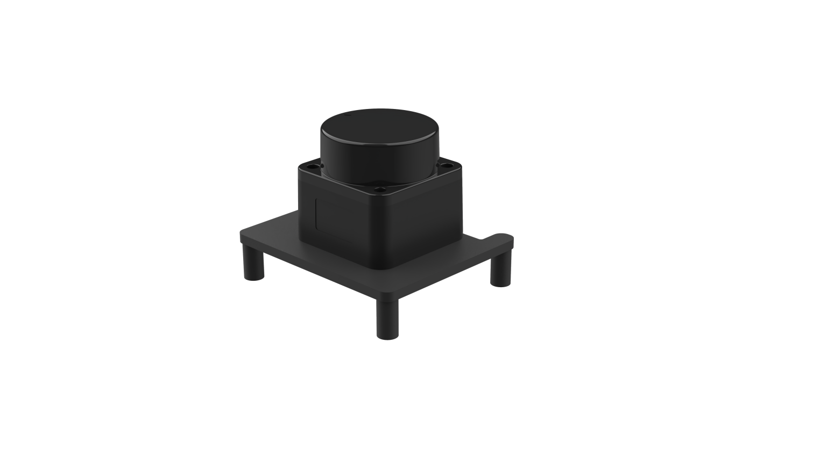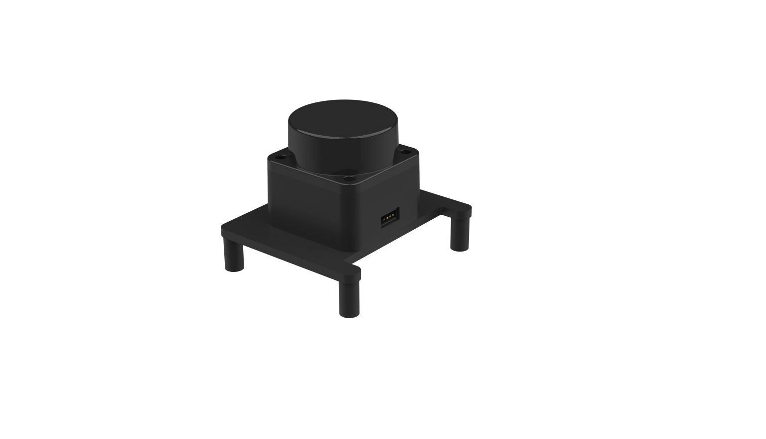

1. DEVELOPMENT KIT 3

2. INSTALL RASPBIAN OS ON SD CARD 4

STEP1: Download a Raspbian OS 4

STEP2: Flash Raspbian OS into SD card 4

3. INSTALL ROS MELODIC ON RASPBIAN OS 5

STEP1: Install Dependecies and Download the Packages 5

STEP2(OPTIONAL): Solve the ERROR: 5

STEP3: Install Melodic Desktop 6

STEP4: Fix the Issues 6

STEP5: Build and Source the Installation 7

STEP6: Install udev liarary、gcc、wiringPi . 7

4. START SERIAL ttyS0 8

5. INSTALL LIDAR ROS PACKAGE 10

STEP1: Device connection 10

STEP2: ROS DTOF_LD06 Driver Compile 11

STEP3: RVIZ results 11

6. USE CAUTION 13

Temperature 13

Ambient lighting 13

Power demand 13

## DEVELOPMENT KIT

The development kit of DTOF LiDAR_LD06 is an accessory tool (includes bracket & DTOF module & Uart cable & Assembly screws) provided for robotic device development or performance evaluation of sensor products, and for the educational purpose use of robotic device motion control and algorithm study,Users need to purchase a RPI SBC ( Raspberry PI3 A+/B+, Raspberry PI3 B, Raspberry PI 4B) to pair with DTOF module for use/development.

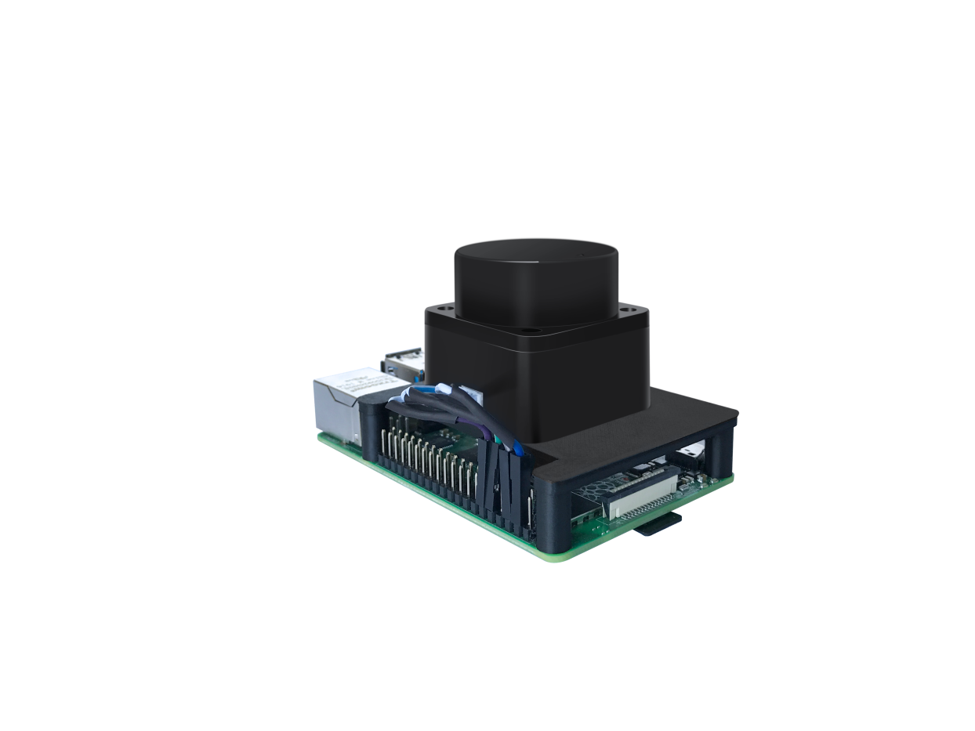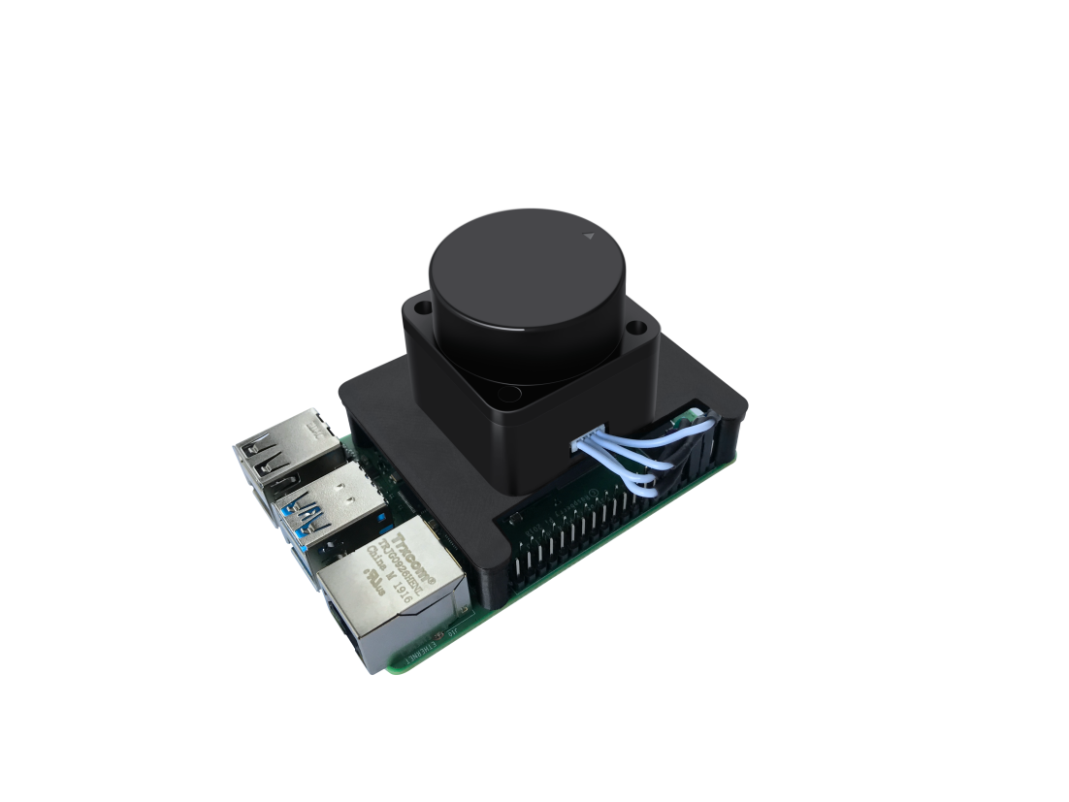

(a) TOFLIDAR_LD06 (b) Uart cable (c) raspberry pi 4B /PI 3B/PI3 A+/Pi3 B+

FIG 1 TOFLIDAR_LD06 DEVELOPMENT KIT

CHART 1 TOFLIDAR_LD06 DEVELOPMENT KIT DESCRIPTION

|  |  |  |
| --- | --- | --- |
| Item | Qty | Description |
| TOFLiDAR_LD06 | 1 | Detection product for space detection and obstacle recognition |
| Uart cable | 1 | Use for connection between the DTOF and Raspberry pi 4B for power and data transfer |
| Raspberry pi 4B | 1 | As a computing tool for the TOF lidar data analysis and visualization into to display device |

## INSTALL RASPBIAN OS ON SD CARD

### STEP1: Download a Raspbian OS

To install Raspbian OS on a SD Card you will need to download a Raspbian OS firstly. User may download the Rasbian OS directly from the official website of raspberry foundation, Ldrobot TOF lidar user manual is based on the version of Raspberry Pi OS (32-bit) with desktop and recommended software as highlighted in the figure 2.

<https://www.raspberrypi.org/downloads/raspberry-pi-os/>

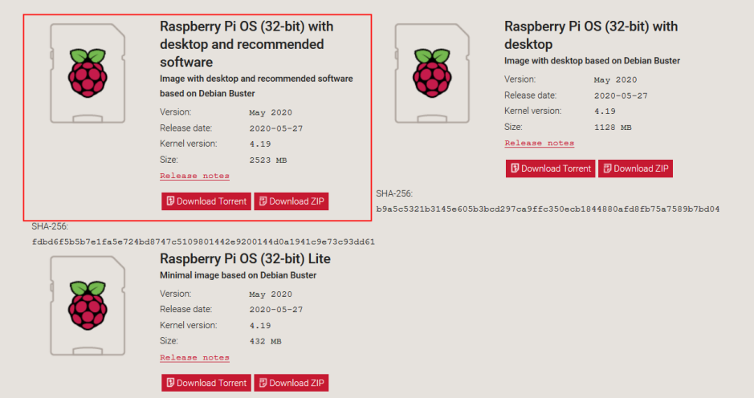

FIG 2. RASPBERRY OFFICIAL WEBSITE

**STEP2: Flash Raspbian OS into SD card**

After downloading a Raspbian OS, you need to install win32diskimager as the tool to flash Raspbian OS into SD card. After the image file has been flashed into the SD card sucessfully , SD card will automatically display a boot partition.

*<https://sourceforge.net/projects/win32diskimager/>*

## INSTALL ROS MELODIC ON RASPBIAN OS

Powering up the Raspberry Pi. And then insert the Micro SD card into the Pi SD-cage . Connects the Mini-HDMI cable to your display ,connect mouse and keyboard . Plug in the power cable to turn on the Raspberry Pi. Then modify the source file of Rasbian OS.

|  |
| --- |
| sudo vim /etc/apt/sources.list  deb http://mirrors.ustc.edu.cn/raspbian/raspbian/ buster main contrib non-free rpi |

### 

### STEP1: Install Dependencies and Download ROS source packages

|  |
| --- |
| sudo sh -c 'echo "deb http://packages.ros.org/ros/ubuntu $(lsb_release -sc) main" > /etc/apt/sources.list.d/ros-latest.list'  sudo apt-key adv --keyserver 'hkp://keyserver.ubuntu.com:80' --recv-key C1CF6E31E6BADE8868B172B4F42ED6FBAB17C654  sudo apt-get update  sudo apt-get install -y python-rosdep python-rosinstall-generator python-wstool python-rosinstall build-essential cmake |

 

Then initialize rosdep and update it

|  |
| --- |
| sudo rosdep init  rosdep update |

### STEP2(OPTIONAL if necessary): Solve the ERROR:

ERROR :cannot download default sources list from: <https://raw.githubusercontent.com/ros/rosdistro/master/rosdep/sources.list.d/20-default.list> Website may be down.

|  |
| --- |
| sudo vim /etc/hosts |

Add 151.101.76.133    raw.githubusercontent.com

Then reinitialize rosdep and update it

|  |
| --- |
| sudo rosdep init  rosdep update |

### STEP3: Install Melodic Desktop

You need to create a dedicated catkin workspace for building ROS and move to that directory.

|  |
| --- |
| mkdir ~/ros_catkin_ws  cd ~/ros_catkin_ws  rosinstall_generator desktop --rosdistro melodic --deps --wet-only --tar > melodic-desktop-wet.rosinstall  wstool init -j8 src melodic-desktop-wet.rosinstall |

The command will take a few minutes to download all of the core ROS packages into the src folder. If wstool init fails or is interrupted, you can resume the download by running:

|  |
| --- |
| wstool update -j 4 -t src |

### STEP4: Fix the Issues

Let’s install the compatible version of Assimp (Open Asset Import Library) to fix collada_urdf dependency problem.

|  |
| --- |
| mkdir -p ~/ros_catkin_ws/external_src  cd ~/ros_catkin_ws/external_src  wget http://sourceforge.net/projects/assimp/files/assimp-3.1/assimp-3.1.1_no_test_models.zip/download -O assimp-3.1.1_no_test_models.zip  unzip assimp-3.1.1_no_test_models.zip  cd assimp-3.1.1  cmake .  make  sudo make install |

The user need to install OGRE for rviz ,too

|  |
| --- |
| sudo apt-get install libogre-1.9-dev |

The next step is to use the rosdep tool for installing all the rest of the dependencies:

|  |
| --- |
| cd ~/ros_catkin_ws  rosdep install --from-paths src --ignore-src --rosdistro melodic -y |

### STEP5: Build and Source the Installation

Once it has completed downloading the packages and resolving the dependencies you are ready to build the catkin packages.

|  |
| --- |
| sudo ./src/catkin/bin/catkin_make_isolated --install -DCMAKE_BUILD_TYPE=Release --install-space /opt/ros/melodic -j2 |

Now ROS Melodic should be installed on your Raspberry Pi 4. We will source the new installation with following command:

|  |
| --- |
| echo "source /opt/ros/melodic/setup.bash" >> ~/.bashrc |

Try launching roscore to check if everything was successful.

|  |
| --- |
| roscore |

### STEP6: Install udev liarary、gcc、wiringPi .

Our driver depends on udev library,so udev library needs to be installed firstly.

|  |
| --- |
| sudo apt-get install libudev-dev |

Then install GCC-5.

|  |
| --- |
| sudo apt remove gcc  sudo apt install -y g++-5 gcc-5  sudo update-alternatives --install /usr/bin/gcc gcc /usr/bin/gcc-5 10  sudo update-alternatives --install /usr/bin/gcc gcc /usr/bin/gcc-5 20  sudo update-alternatives --install /usr/bin/g++ g++ /usr/bin/g++-5 10  sudo update-alternatives --install /usr/bin/g++ g++ /usr/bin/g++-5 20  sudo update-alternatives --install /usr/bin/cc cc /usr/bin/gcc 30  sudo update-alternatives --set cc /usr/bin/gcc  sudo update-alternatives --install /usr/bin/c++ c++ /usr/bin/g++ 30  sudo update-alternatives --set c++ /usr/bin/g++ |

Then install wiringPi,WiringPi has updated to 2.52 for the Raspberry Pi 4B.

|  |
| --- |
| cd /tmp  wget https://project-downloads.drogon.net/wiringpi-latest.deb  sudo dpkg -i wiringpi-latest.deb |

After wiringPi being updated ,you can check with the latest version update

|  |
| --- |
| gpio -v |

## START SERIAL ttyS0

|  |
| --- |
| sudo raspi-config |

Open the system configuration interface as shown in the figure below, and select the **interface options.**

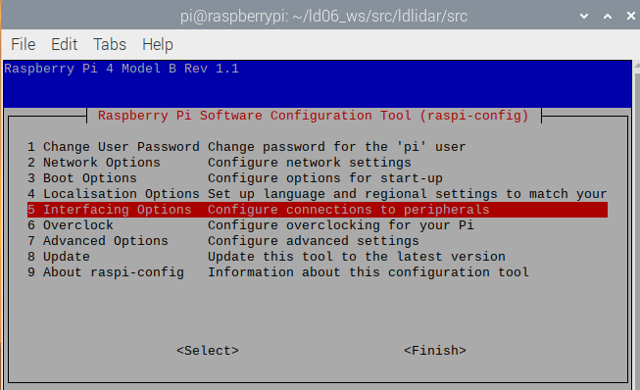

FIG 3. RASPBERRY SYSTEM CONFIGURATION I

Then select **P6 serial.**

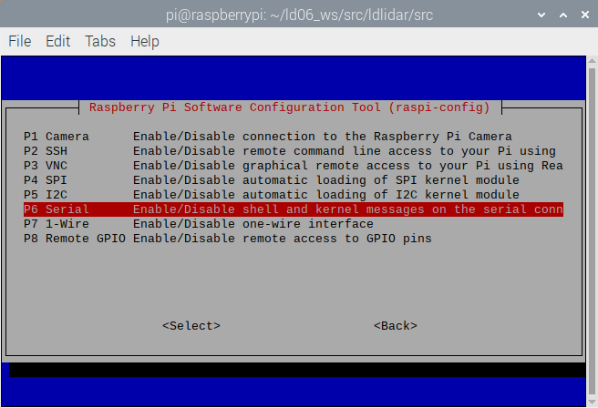

FIG 4. RASPBERRY SYSTEM CONFIGURATION II

Then click **Yes**.

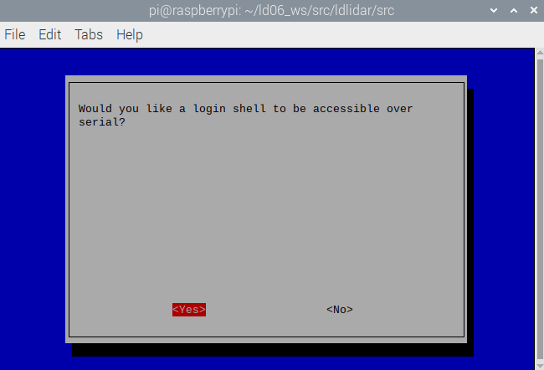

FIG 5. RASPBERRY SYSTEM CONFIGURATION III

Then Save and exit. Restart raspberryPi4. Check if the serial port is open. View serial port mapping relationship

|  |
| --- |
| ls -l /dev |

 

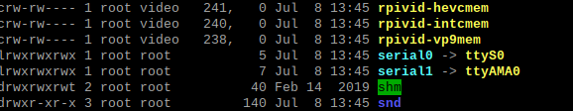

FIG 6. RASPBERRY SERIAL PORT MAPPING

Serial0 is the serial port corresponding to the GPIO pin. If you see serial0 connected to ttys0, the serial port configuration is successful.

## INSTALL LIDAR ROS PACKAGE

### STEP1: Device connection

Connect Lidar and Raspberry Pi 4B as shown in the figure below. 5v connect 5v Power,GND connect Ground,Motor PWM connect BCM18(pwm0),Lidar Uart TX connect BCM15(RXD).

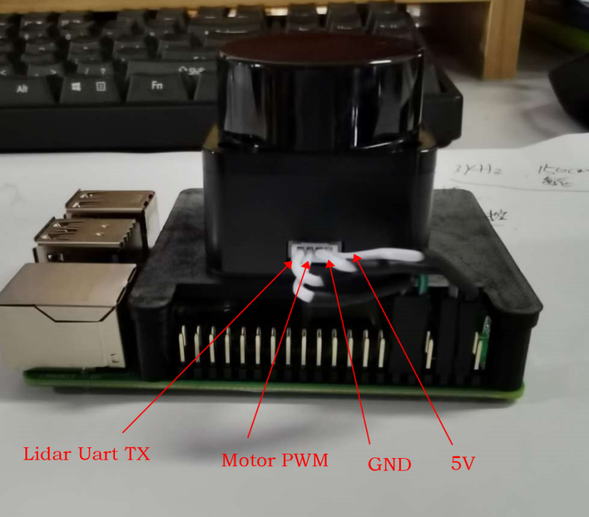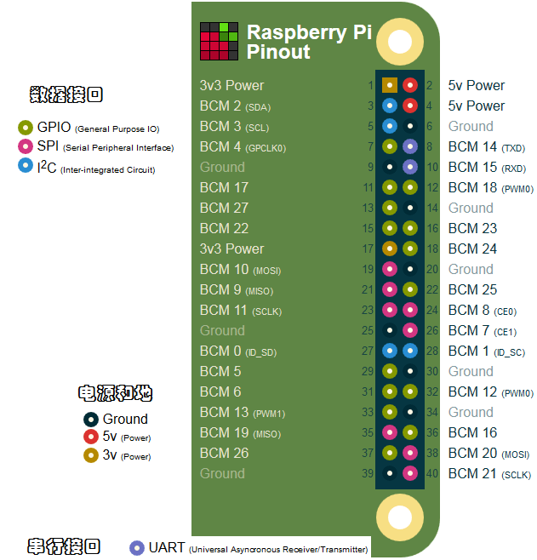

FIG 7. CONNECTION BETWEEN LIDAR AND RASPBERRY PI 4B

The users need to have the root permission of raspbian kernel system. After connecting TOF LiDAR_LD06 with raspberry pi 4B/3B/3B+/3A+; you need to log in to root as first step. The password of the raspberry 4 B is raspberry. (low-case )

$ **su**

Enter passwd : raspberry

### STEP2: ROS DTOF_LD06 Driver Compile

The ROS driver package Ld06_ros_driver has been uploaded into the ld06_ws/src directory. You just acess the ld06_ws workspace and compile.

$ **cd /home/pi/ld06_ws**

$ **catkin_make**

$ **source devel/setup.bash**

$ **roslaunch ldlidar ld06.launch**

### STEP3: RVIZ results

After running the launch file, open rviz to view the TOF LiDAR_LD06 scan results, as shown in the following figure:

$ **rosrun rviz rviz**

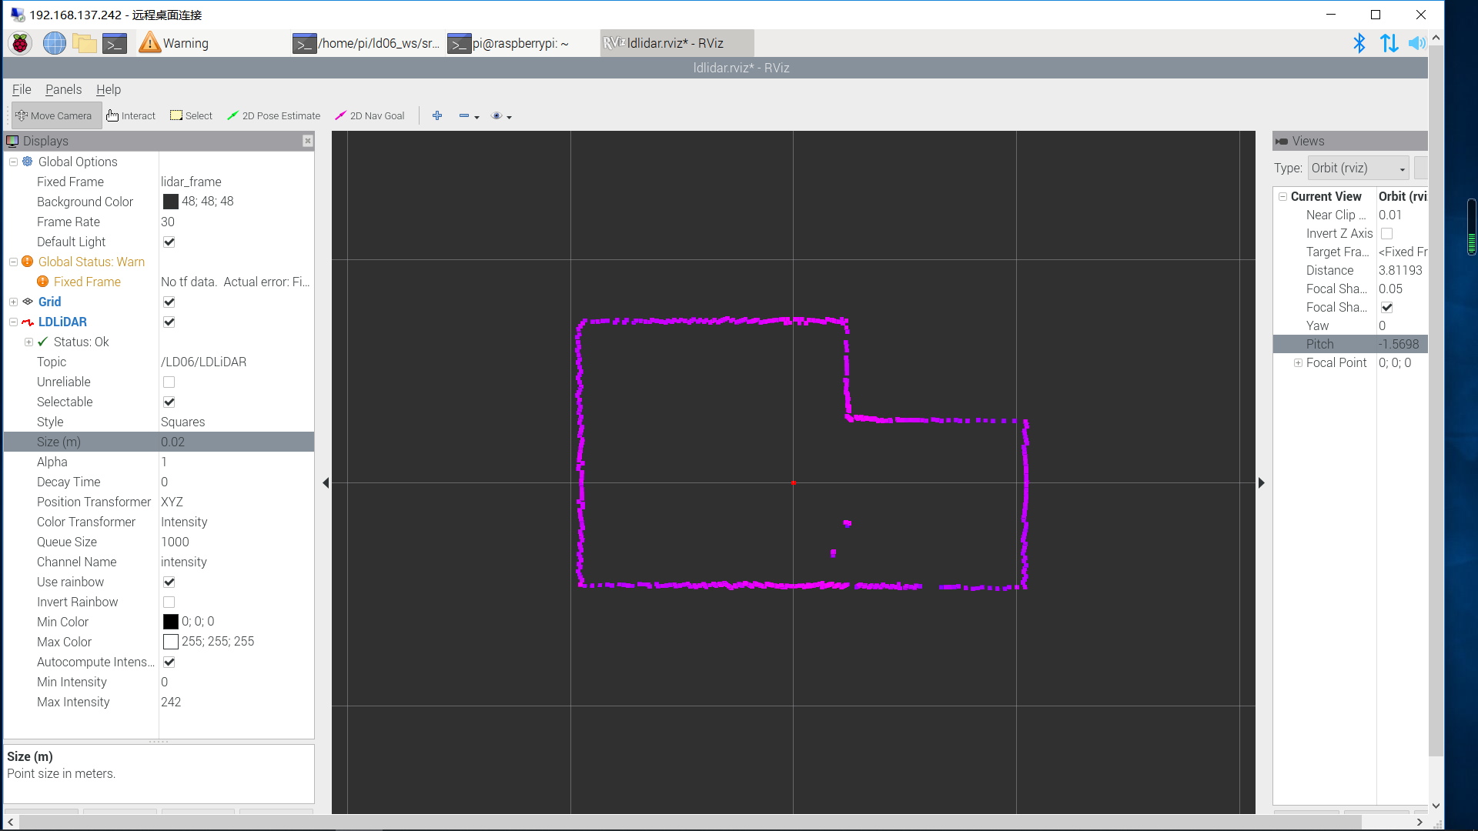

FIG 8 TOFLiDAR_LD06 RVIZ

## USE CAUTION

### Temperature

When the working environment temperature of TOFLiDAR_LD06 is too high or too low, it will affect the accuracy of the distance measuring system. It may also damage the structure of the scanning system and reduce the life of the TOFLiDAR_LD06. Avoid use in high temperature (>40 degrees Celsius) and low temperature (<0 degrees Celsius) conditions.

### Ambient lighting

The ideal working environment for the Lidar is indoor, indoor lighting (including no light) will not affect it work. Don’t using a strong light source (such as a high-power laser) to directly illuminate the lidar's vision system.

If you need to use it outdoors, please avoid that the its vision system is directly facing the sun. This may cause permanent damage to the vision system's sensor chip, thus invalidating the distance measurement.

Please note that the Lidar standard version is subject to interference in outdoor strong sunlight reflection environments.

### Power demand

For development ,both external adaptor or independent power bank works , but need to ensue 5V and 200MA current power input, for external adaptor solution,the Raspberry Pi SBC adaptor is the preference choose.

*Note: Please connect the TOFLiDAR_LD06 before you power up the raspberry.*